The ERE can also be used to help with TMJ and Headaches

For TMJ – Place 2 pads just under and behind the ear
Place 2 pads just in front of the ear where your jaw hinges
See Figure 3
Make sure the dials are turned down all the way to the left (counterclockwise)
Set the Function to “Pads”, the Mode to “Massage” and slowly turn up the dials
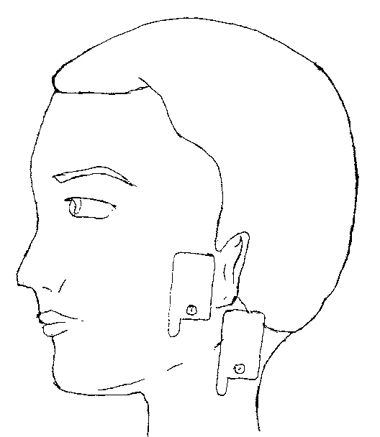

Figure 3

For Headaches – Place two pads at the temples
Place two pads just below and behind the ear
See Figure 4
Make sure the dials are turned down all the way to the left (counterclockwise)
Turn the Function to “Pads”, the Mode to “Massage” and slowly turn up the dials
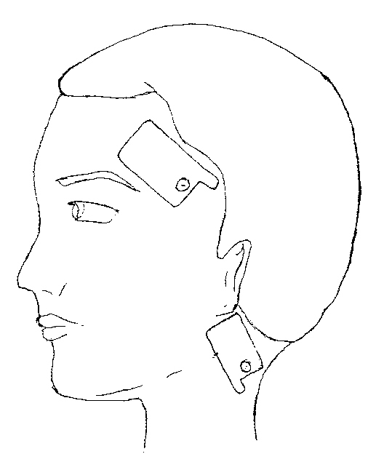

Figure 4

*Note – You may use any Mode you prefer, “Massage” is simply the most common.

