Massage Aids for the ERE

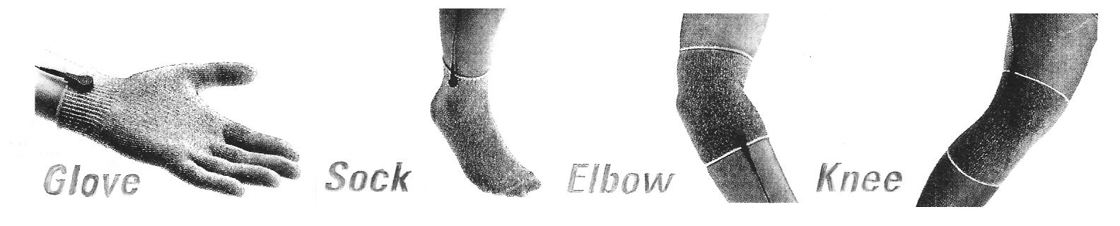

You can use a conductive glove, sock, knee or elbow garment with the ERE. Simply remove one of the sticky pads by the snap and attach the wire to the conductive garment by the snap. Wet the garment with water and some mild soap (for better conductivity). Place the garment on your body and the pad on the largest muscle near the affected area (as a dispersive electrode), and turn the dial all the way down. Set the ERE function to “PADS” and the mode to whichever setting you choose, though most people prefer “RELAX” or “MASSAGE”. Turn the intensity all the way up on the machine. Then slowly turn up the dial on the pads to what is comfortable.

- To use the glove on another person simply place the glove on your hand, put a pad on the largest muscle that is closest to the area you are going to go over, and rub the affected area with the glove. Make sure you have PERMISSION to touch them.

- To use the glove to massage yourself, place a rubber glove on your hand under the massage glove. Place a pad on the largest muscle that is closest to the area you are going to go over, and rub the affected area with the glove.

- You can use the massage glove to treat areas the ERE pads can’t access, like the head. The conductive glove can go up through the hair and deliver the benefits of the ERE.

- The conductive sock can be used to give the benefits of the ERE to people who are unable to place their feet on the ERE.

- Instead of using a pad as a dispersive electrode, you can also use the conductive elbow garment with the glove, or the conductive knee garment with the sock as the dispersive electrode.

*These may help with swelling, arthritis, Carpal Tunnel, and pain by increasing circulation.

These conductive garments can be purchased from Sudweeks Distributing
Email us at sudweeks@sudweeksdistributing.com or call 801-785-2711

