What is far-infrared heat?

Infrared light is part of the sun's invisible spectrum. One of Far-Infrared light's characteristics is the ability to easily penetrate human tissue. When this happens, it creates a natural resonance, which has many beneficial properties. Remember the last time you were sunbathing with sunscreen? Were you still hot? Of course you were because the sunscreen only stops the UV (Ultraviolet) light from hitting your skin. The Far-Infrared heat (FIR light waves) penetrates your skin, giving you that wonderful natural warmth. You can be exposed to Far-Infrared heat for hours and it will never cause your skin to burn. Far-Infrared heat is completely healthy and safe for all living things.

Dr. Toshiko Yamazaki, M.D. owns a clinic in Japan where she has done extensive research on the therapeutic uses of far-infrared. In her book, "The Science of Far-Infrared Therapies," she explains that one of the reasons FIR (Far-Infrared) has beneficial results in a variety of illnesses is the ability of FIR waves to remove toxins, which are often at the core of many health problems. Since humans are bio-accumulators, toxins that cannot be expelled immediately after entry are stored in our bodies. For example, when toxic gases such as sulphur dioxide, carbon dioxide or toxic substances such as lead, mercury or chlorine meet large water molecules, they are encapsulated by the clusters of water. Where these toxins are accumulated, blood circulation is blocked and cellular energy is impaired. However, when an 8-10 micron FIR wave is applied to these large water molecules, the water begins to vibrate. This vibration reduces the ion bonds of the atoms which are holding together the molecules of water. As the breakdown of the water molecules occurs, encapsulated gases and other toxic materials are released.
What is the best infrared frequency?
All humans send and receive FIR waves. The range of far-infrared waves generated by the human body is 6 to 20 microns. The optimal micron output range is between 8 to 10 microns which is very close to the resonant frequency of a water molecule. This similarity makes sense since our bodies are almost 70% water. This range, sometimes called "Vital Rays" appears to have special regenerative effects on the body.

The HotHouse Far infrared unit performance is well within this vital wave range of 8-10 microns with a good portion of wavelengths at 9.4--which is the frequency at which a water molecule resonates or vibrates. This vibration causes a release of cellular toxins such as mercury, aluminum, cholesterol and other toxic gases such as sulfur and formaldehyde. This optimal micron output also allows for deeper penetration of far-infrared heat, which improves pain relief, detoxification, circulation, and increased peripheral blood flow.

Why doctor's recommend infrared

FIR waves provide concentrated radiant energy, similar to that from the sun. When any tissue in the body is exposed to FIR waves, there is a rapid increase in warmth which can be shown by thermography. This heat plus the activation of several other response mechanisms stimulates the healing processes.
For example, FIR waves:

1. Increase blood flow by promoting dilation (expansion) of the micro-circulatory system of capillaries.

2. Reduce muscle spasms as muscle fibers are heated.

3. Remove toxins from the site receiving FIR waves.

4. Assist in the reduction of swelling and inflammation by improving lymph flow.

5. Reduce soreness through direct action on both free nerve endings in tissues and on peripheral nerves. At the cellular level, researchers have discovered the FIR wave lengths between 8-10 microns:

1. Stimulate enzyme activity.

2. Promote the adhesion and osmosis of water molecules across the cellular membrane.

3. Attract calcium ions to the cellular membrane. FIR waves of the sun are that part of the light spectrum most responsible for the ripening of fruits which converts other carbohydrates into sugar. This process of reducing acidity can be tested by putting half a lemon in the sun for one of two days or. on an infrared coated plate for about one hour. The infrared exposed half will be significantly sweeter than the other half.

Safety of farinfrared heat

Infrared light is part of the Sun's invisible spectrum. One of Far-Infrared light's characteristics is the ability to easily penetrate human tissue. When this happens, it creates a natural resonance, which has many beneficial properties. Remember the last time you were sunbathing with sunscreen? Were you still hot? Of course you were because the sunscreen only stops the UV (Ultraviolet) light from hitting your skin. The Far-Infrared heat (FIR light waves) penetrates your skin, giving you that wonderful natural warmth.

You can be exposed to Far-Infrared heat for hours and it will never cause your skin to burn. Far-Infrared heat is completely healthy and safe for all living things. In fact, far-infrared heat is so safe it is used in hospitals to warm newborn infants.

Infrared Health Benefits
. Pain Relief
. Weight Loss
. Detoxification
. Increases Circulation
. Cholesterol Removal
. Boosts Immune System
. Normalizes Blood Pressure
. Fibromyalgia Pain Relief
. Removes Cellulite & Cleanses Skin
. Reduces Stress and Fatigue
. Speeds Healing to Cuts and Bruises
. Reduces Swelling and Inflammation
. Improves Joint Stiffness
Far-infrared cellular
purification
Dr. Toshiko Yamazaki, MD owns an infrared therapy clinic in Japan where she has done extensive research on the uses of Far Infrared Therapy or Infrared Light Therapy. In her book, “The Science of Far-Infrared Therapies," she explains that one of the reasons FIR (Far Infrared Therapy) has beneficial results in a variety of illnesses is the ability of FIR waves to remove toxins with mercury detoxification, which is often at the core of many health problems. Since humans are bio-accumulators, numerous toxins that disturb natural body healing and cannot be removed immediately after entry are stored in our bodies and prevent future natural body healing.

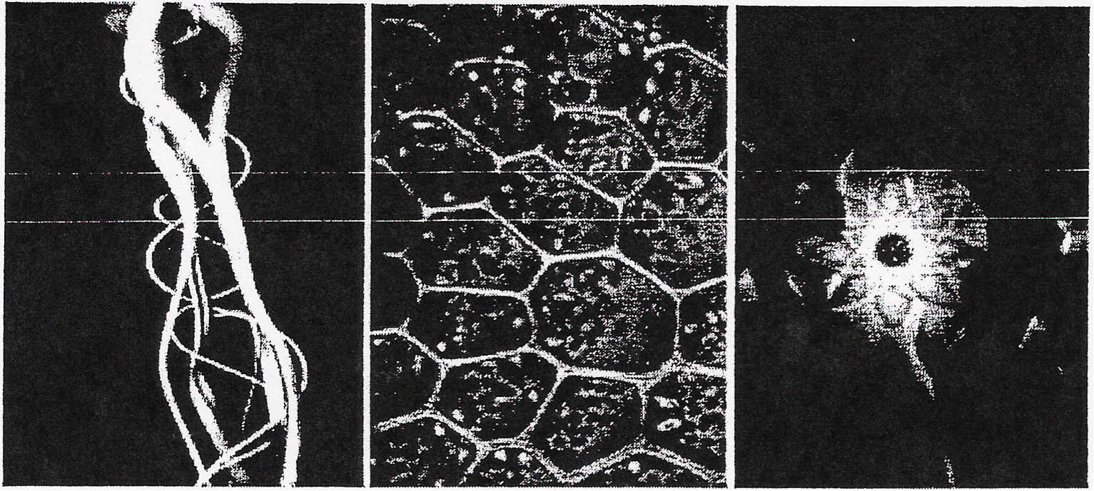

A 10 micron far-infrared Cellular Vibration this vibration reduces
light wave reaches up to occurs when the light the ion bonds of the
2 inches deep inside the waves penetrate the atoms that are holding
body’s tissue cells and reach large together the molecules
water molecules of water, resulting in
a release of toxins

Detoxification
and Far Infrared
Therapy
When toxic gases such as sulphur dioxide and carbon dioxide or toxic substances such as lead, mercury, or chlorine meet large water molecules, water clusters encapsulate them. Where these toxins accumulate, blood circulation is blocked and cellular energy is impaired. Mercury detoxification begins when a 10 micron Far Infrared Therapy wave is applied to these large water molecules and the water begins to vibrate.

This vibration reduces the ion bonds of the atoms that are holding together the molecules of water. As the vibration continues, breakdown of the water molecules occurs and encapsulated gases and other toxic materials are released. Scientists in Japan report that in the Far Infrared Therapy wave treatment of clogged capillary vessels, a similar process occurs: heat expands the capillaries from Far Infrared Therapy and then initiates the process to dissolve hidden toxins.

Far Infrared Therapy also helps to improve nervous disorders, digestive disorders, weight loss, and normalize blood pressure.

*******************************************************************************************************

Case Reports (HotHouse)

Ken's Story

"Anyone who has suffered from shingles knows what I am talking about when I say that the pain associated with this illness is intense. Never before have I experienced anything so painful. Seven years ago I had my first attack of shingles. It lasted about 2 % to 3 weeks, the medication from the doctor was expensive and almost impossible to use, as it was very thick and very painful to apply.

My second attack happened just 2 weeks ago. During the night I woke up thinking that I was having a heart attach, then realized that I had the shingles again. Not knowing what else to do I got up and took the HotHouse out and sat on the couch with it around my back, quite close to my skin. I used it that fist time for about 1 % hours. The pain was completely gone!!! That was amazing; with shingles the pain is usually continuous.

By using the HotHouse whenever I felt any pain come on, I was able to be completely free from the shingles within about 4 days.
During the 4 days, I was able to function normally and the pain completely
went away. This is a vast difference from the first time I had shingles.
The pain was so bad the first time that I could not sit in a chair, wear a shirt (the weight of the material against my skin was too painful) or conduct any daily affairs.

Once more the HotHouse has paid for itself!!! I have to say again, that I would never again be without either one of these machines in my home".

-Ken Cook Lethbridge, AS Canada

----------
Dave's Story

My name is David and my wife, Mary and I were first introduced to the Chi machine from a friend of ours who told us it helped with sleeping among many
other things. We had lost two young people very close to our family in two separate car accidents. I also snored a lot at night and was not sleeping well as it was. I could not believe what happened after the first night we used the machine. The Chi machine put us into a perfect deep sleep, and my wife said I never snored or moved a muscle. My wife also has problems with her back, and the Chi machine has helped her so much with that.
I had psoriasis on the front part of my leg from the knee to the ankle. I had scabs and sores, and it was very annoying because it itched a lot. This
is something I have had for at least four years. After hearing the
testimonies of how the Hot House helps with sores and rashes, I decided to use it on my leg. The first day I used the Hot House for three hours and put my leg as close to the Hot House as I could. I followed up the next two
evenings for about two hours, and after the second evening, the blemishes
were totally gone. The skin was pink under the area where the rash was. It has been over a month now and the psoriasis has not come back. The area
where my psoriasis was is a bit lighter than the rest of my leg.

Getting rid of my psoriasis has made me a strong believer in the Hot House and what the potential for this amazing machine is.

Mary and I are very grateful for being introduced to the Chi machine and the Hot House. WE feel it is our obligation to share this with as many people as we can so that they can experience the wonderful things that can happen with these two machines".

Dave and Mary S.

--

Neil's Story

"Dear Dr. Lipton,

Thanks for recommending the FIR HotHouse - I was in terrible pain -- gone to every doctor, MRI, the works - I have bone spurs, and two bulging disks in my back.

I was bedridden, taking pain pills and having trouble back spasms - I had made an appointment with a pain specialist when I remembered Dr. Lipton's FIR machine (ie the HotHouse) - I had one air freighted to my house.

What a miracle! In seven days, no medicine was needed - my wife even started using Hot House for her siesta with great relief.

Thank you,
Your friend"
Neil C. Henriksen

-----
P.K’s Story

Once a year I get a yeast infection. When I felt the familiar symptoms of itching and burning, I went under the HotHouse for 2 hours while I slept. The next day, the itching was reduced. I did the same thing that night and the next day all of the symptoms had disappeared.
Curtis' Story

"I am 19 years old and have suffered from asthma and allergies most of my life.
A few weeks ago I had a bad cold, with a 102-degree fever, and was having to take nebulizer treatments every four hours or sooner. The first night we had our far-infrared dome, my nose was plugged up, my lungs were tightening, and I was feeling like I needed to take another treatment, but I laid under the far-infrared done instead. One and a half or two hours later, when I got up, I could breathe deeply and my nose was opened up!

Because of my asthma and allergies, in pervious years I haven't even been able to mow the lawn. (One year, mowing the lawn landed me in the hospital for a few days.) But with the far-infrared dome, it's a different story.

Yesterday I was running a thatcher on the yard and the wind blew grass clippings all over me. Something like this normally would have made me
start sneezing and by evening I would have had an asthma attack. It was a war, muggy day and after using the dome, nearly 24 hours later, I haven't had an attack and my nose is not worse than usual - and that's amazing. With the far-infrared dome, I no longer have to take any of my asthma medicine".

-Curtis Gordon

-----

Annie's Story

August 16, 2000

Early this year, my Mother, Annie Glenn, age 86, learned she had colon cancer. Extensive surgery was done in March to remove part of the color and rectum. She spent 6 weeks in the hospital recuperating.

Following dismissal from the hospital, we were told the cancer had spread to
the lymph nodes in that area. Chemotherapy and radiation were recommended but it was decided she was too weak for both treatments, so radiation was ruled out. Six months of chemotherapy, once weekly, was prescribed and started.

I decided to put Mother under the Hot House Far-Infrared Dome 3 to 4 hours daily, focusing of course on the affected area. After 7 weeks of chemo, she was so weak from the effects of it, she was put back in the hospital for a week.

Extensive blood work was done plus a CAT scan. The Oncologist was amazed to find there were no signs of cancer. He asked "What have you been doing?" Six months of chemo and radiation was thought to be the only hope.

Today, August 16, I took my Mother back to her Oncologist and there is still no sign of cancer. She continues to grow stronger. And she continues to
. use the Hot House daily".

