Home Face-Lifts

If you have wrinkles and an Advanced ERE, you can give yourself a face-lift in the comfort of your own home!

- Make sure the dials on the pads are turned all the way down. Double-check this again before you start, since they have a tendency to slip.

- Plug in the pads to the ERE

- Place the pads on your face (see Figures 1 and 2)

- Turn on the ERE with the remote and set the Function to “Pads”
We suggest setting the Mode to “RELAX” or “MASSAGE”,

- Turn the intensity all the way up.
(Remember to double-check the dials on the pads first)

- Turn the dials up SLOWLY until you feel the muscles moving

- Use for 5-15 minutes

- The effects will become more permanent the more often you use it.

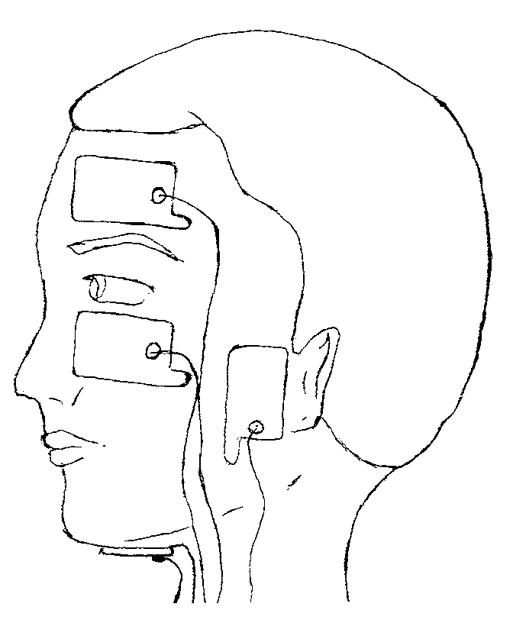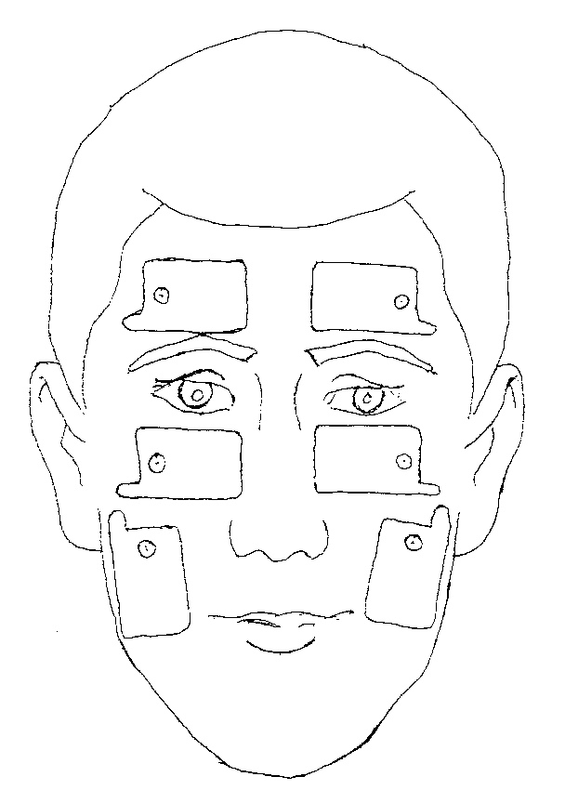
Figure 1 Figure 2

Place the pads above your eyebrows for forehead wrinkles.
Place the pads under your eyes for baggy eyes.
Place the pads in front of your ear to tighten mouth and cheeks.
Place the pads under your chin to tighten jowls.

